CAPSTONE PROJECT WORK REPORT
Phase I
AI Resume Analyzer and Job Recommendation System

RASHVANDH A
(REG. NO. 2428C0504)
A report submitted in partial fulfilment of the degree of
B.Sc. Artificial Intelligence and Machine Learning

Under the Guidance of
Dr.M.Vaishnava Priya M.Sc., M.Phil., Ph.D.
Associate Professor, Dept. of AI and ML


Department of Artificial Intelligence and Machine Learning
KPR College of Arts Science and Research

(Affiliated to Bharathiar University, Coimbatore)
Avinashi Road, Arasur, Coimbatore – 641407.

March 2026

CAPSTONE PROJECT WORK REPORT
Phase I
AI Resume Analyzer and Job Recommendation System
Bonafide Work Done by
RASHVANDH A
(REG. NO. 2428C0504)
Dissertation submitted in partial fulfillment of the requirements for the award of
B.Sc. Artificial Intelligence and Machine Learning of
Bharathiar University, Coimbatore-46.


Signature of the Guide Signature of the HOD

Submitted for the Viva-Voce Examination held on ____________

Internal Examiner External Examiner

March 2026

Acknowledgement

I am writing this acknowledgement to express my deepest gratitude for the support and guidance you have provided me during the course of my capstone project.

I would like to convey my profound gratitude to Dr. P. Geetha, Principal of KPR College of Arts Science and Research, for her endless support. I would also like to extend my sincere thanks to Dr. K. Pradeepa, Dean, School of Intelligence System and Data Science, and beloved Dr. R. Kumathaveni M.C.A., M.Phil., Ph.D., SET, NET, Associate Professor & Head, Dept. of AI and ML, for providing moral support and motivation throughout the project.

It’s my privilege to thank my guide Dr.M.Vaishnava Priya M.Sc., M.Phil., Ph.D., Assistant professor, Department of Artificial Intelligence and Machine Learning, for her valuable support and suggestions. I feel privileged to have had the opportunity to learn form her, and I am grateful for the valuable lessons and experiences that I have gained under her guidance.

Student Signature
Place: Coimbatore
Date:

Section No. | Section Title | Page No.
 | Acknowledgement | 3
 | Contents | 4
 | Synopsis | 5
1. | Introduction  1.1 Organization Profile  - System Specification  - Hardware Configuration  - Software Specification | 6-8
2. | System Study  - Existing System  - Drawbacks  - Proposed System  - Features | 9-10
3. | System Design and Development  - File Design  3.2 Input Design  3.3 Output Design  3.4 Database Design  3.5 System Development  3.6 Description of Modules (Detailed explanation) | 11-16
4. | Software Testing and Implementation | 17-19
5. | Conclusion | 20
6. | Bibliography | 21
7. | Appendices  - Data Flow Diagram  - Table Structure  - Sample Coding  - Sample Input  - Sample Output | 22-29
CONTENTS

Synopsis

In today’s highly competitive job market, organizations receive an overwhelming number of resumes for each job opening. Manual screening of resumes is time-consuming, inefficient, and often influenced by human bias.
The AI Resume Analyzer and Job Recommendation System is designed to automate resume evaluation using Artificial Intelligence and Natural Language Processing techniques.The system allows users to upload resumes in PDF or text format. It extracts important information such as skills, education, experience, and projects using text processing techniques.
The extracted information is then analyzed using TF-IDF vectorization and cosine similarity algorithms to match candidate resumes with job descriptions stored in the system database. The platform also calculates an ATS (Applicant Tracking System) score based on multiple evaluation parameters such as skill relevance, experience depth, resume structure, keyword density, and project impact.
Additionally, the system integrates an AI chatbot module powered by Large Language Models (LLMs) that provides career guidance and resume improvement suggestions. The system is implemented using a FastAPI backend for high-performance processing and a modern web frontend built using HTML, CSS, and JavaScript.
By automating resume screening and job recommendation, the system helps recruiters identify suitable candidates efficiently and enables job seekers to improve their resumes and career prospects.

1.Introduction
With the rapid growth of digital recruitment platforms and online job portals, organizations are receiving an unprecedented number of job applications. Human resource professionals face significant challenges in efficiently reviewing and selecting suitable candidates.
Traditional recruitment methods rely heavily on manual resume screening, which requires considerable time and effort. This process may also result in inconsistent evaluations due to subjective bias and human fatigue.
Artificial Intelligence and Machine Learning technologies provide innovative solutions to automate recruitment processes. By applying Natural Language Processing techniques, resumes can be analyzed to extract meaningful information and determine candidate suitability for specific job roles.
The AI Resume Analyzer and Job Recommendation System is developed to streamline the recruitment process by automatically analyzing resumes, extracting technical skills, calculating ATS scores, and recommending suitable job opportunities.
Project Objectives
The main objective of this project is to design and implement an intelligent system capable of analyzing resumes and recommending job roles.
Specific objectives include:
- Automating resume parsing and extracting candidate information
- Identifying technical skills using keyword detection techniques
- Matching resumes with job descriptions using similarity algorithms
- Generating ATS scores based on resume quality parameters
- Providing resume improvement suggestions
- Integrating AI chatbot for career guidance
- Developing an interactive web application
Significance of the Project
This project helps reduce manual effort in recruitment processes and improves hiring efficiency. It provides data-driven insights to recruiters and offers personalized feedback to candidates.The system ensures unbiased evaluation by relying on machine learning algorithms rather than human judgment.

  - Organization Profile
KPR College of Arts Science and Research (KPRCAS) is a premier institution in Tamil Nadu, established in 2019 under the prestigious KPR Group. Affiliated with Bharathiar University, Coimbatore, the college is dedicated to academic excellence, innovation, and industry-oriented education. Situated in Arasur, Coimbatore, KPRCAS provides a world-class learning environment with a strong emphasis on research and practical knowledge application.
Vision:
To be a globally recognized institution that imparts knowledge and life skills to students, shaping them into responsible citizens who contribute to society’s growth and development.
Mission:
- To provide high-quality education that blends theoretical and practical knowledge.
- To equip students with industry-relevant skills and enhance employability.
- To promote research and development in emerging fields like Artificial Intelligence, Data Science, and Cybersecurity.
- To instill ethical values, leadership qualities, and lifelong learning habits in students.

1.2 System Specification
The AI Resume Analyzer system is designed to perform intelligent resume processing using machine learning and text mining techniques. The system performs the following operations:
- Resume upload and text extraction
- Skill detection and classification
- Job similarity calculation
- ATS score generation
- Resume improvement suggestion generation
- AI chatbot interaction
Component | Specification
Processor | Intel Core i5 / equivalent
RAM | 8 GB or above
Storage | 256 GB SSD
Internet | Required for API access
System Type | 64-bit System
1.3 Hardware Configuration

1.4 Software Specification
Component | Details
Operating System | Windows 11
Development Environment | VS Code
Programming Language | Python
Backend Framework | FastAPI
Frontend | HTML, CSS, JavaScript
Machine Learning | Scikit-learn
NLP | TF-IDF, Cosine Similarity
APIs | Groq API / LLM APIs

2. System Study
The recruitment process is an essential activity for organizations aiming to hire skilled candidates. However, traditional resume screening methods are inefficient when dealing with large application volumes.
Artificial Intelligence provides solutions to automate candidate evaluation by analysing resume content and comparing it with job requirements.
2.1 Existing System
The traditional recruitment process involves manual resume screening performed by HR professionals. Recruiters read each resume individually and compare candidate qualifications with job requirements.
Some organizations use basic Applicant Tracking Systems (ATS) that filter resumes using simple keyword matching techniques. However, these systems often fail to understand semantic meaning and contextual relevance.
2.2 Drawbacks of the Existing System
The current recruitment systems have several limitations:
- Manual Screening: Requires significant human effort and time.
- Human Bias: Recruiters may unintentionally Favor certain candidates.
- Keyword Dependency: Basic ATS systems rely only on exact keyword matches.
- Lack of Feedback: Candidates do not receive suggestions to improve their resumes.
- Limited Intelligence: Existing systems cannot understand the context of candidate skills.
2.3 Proposed System
The proposed system is an AI-powered resume analysis platform that automates candidate evaluation using Machine Learning and Natural Language Processing (NLP) techniques. It automatically extracts key information from resumes, identifies candidate skills and experience, and matches resumes with job descriptions using similarity algorithms. The system also generates ATS scores and provides suggestions to improve resume quality and effectiveness. Additionally, it includes an AI-based chatbot that offers career guidance and helps candidates enhance their job readiness.
2.4 Features
The AI Resume Analyzer provides several advanced features:
- Resume parsing and information extraction
- Skill detection using a technical skill database
- Job recommendation based on resume analysis
- ATS score generation and resume quality evaluation
- Resume improvement suggestions
- AI chatbot for career advice
- Interactive web interface

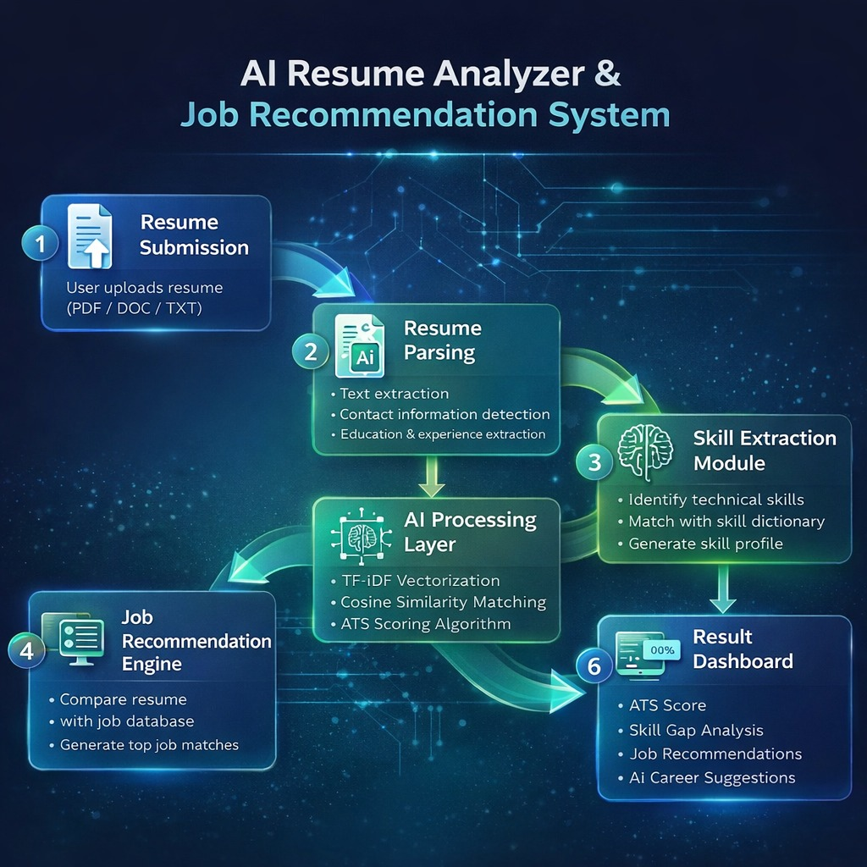

3. System Design and Development
The system design phase focuses on defining the architecture, data flow, input-output structure, database schema, and module functionality of the AI Resume Analyzer and Job Recommendation System.
The development process follows a modular architecture to ensure scalability, maintainability, and performance optimization.
3.1 File Design
The project is divided into multiple files to maintain modularity and improve code reusability.
1.Backend Server File (backend_main.py)
This file acts as the core processing engine of the system.
Functions performed:
• Handles resume upload requests
• Extracts text from resume files
• Performs skill extraction
• Calculates ATS score
• Computes job similarity using TF-IDF
• Communicates with AI chatbot API
• Sends processed results to frontend
2. Resume Parsing Module (resume_parser.py)
Responsible for extracting structured information from raw resume text.
Tasks performed:
• Email detection using Regular Expressions
• Phone number extraction
• Experience keyword detection
• Education identification
• Section classification

3. Skill Dictionary File (skills_db.json)
Contains categorized technical skills.
Example categories:
• Programming Languages
• Web Development
• Cloud Technologies
• Data Science Tools
• Databases
4. Job Database File (job_database.json)
Stores job descriptions.
Each record contains:
• Job ID
• Job Title
• Job Category
• Required Skills
• Job Description
5. Frontend File (index.html)
Provides interactive user interface.
Features include:
• Resume upload
• Skill visualization
• ATS score dashboard
• Job recommendation cards
• Chat interface

3.2 Input Design
Input design ensures that the system accepts user data efficiently and validates it before processing.
Input Type
The system accepts:
• PDF Resume Files
• Text Resume Files
Input Process
- User uploads resume through drag-and-drop interface
- File is converted into raw text
- Text is cleaned using preprocessing techniques
- Important keywords and sections are extracted
Validation
• File type validation
• File size validation
• Empty content detection
• Unsupported format rejection
3.3 Output Design
The system generates multiple outputs for better user understanding.
1. ATS Score Output
Displays overall resume quality score (0–100)
Breakdown includes:
• Skill Match Score
• Experience Score
• Resume Structure Score
• Keyword Density Score

2. Job Recommendation Output
Displays:
• Top 5 matching job roles
• Match percentage
• Missing skills
3. Improvement Suggestions Output
Examples:
• Add measurable achievements
• Include more technical projects
• Improve skill keyword coverage
4. Chatbot Output
Provides real-time career advice.
3.4 Database Design
The system uses structured JSON-based in-memory databases.
Job Table Structure
Field | Description
job_id | Unique Identifier
job_title | Name of Role
category | Field of Job
skills | Required Skills
description | Job Overview

Skill Table Structure
Field | Description
skill_name | Technology Name
category | Skill Type
importance_weight | Matching Priority

3.5 System Development
The system is developed using an agile methodology.
Development Steps
- Requirement analysis
- Resume dataset preparation
- Skill extraction module implementation
- TF-IDF similarity engine development
- Backend API creation
- Frontend UI development
- Integration testing
- Deployment
Technology Stack
Backend → FastAPI
Frontend → HTML CSS JavaScript
Machine Learning → Scikit-learn
AI Integration → Groq API
Text Processing → TF-IDF
3.6 Description of Modules
1.Resume Extraction Module
The Resume Extraction Module converts uploaded resume files into analyzable text by using PDF parsing techniques. It cleans the data by removing special characters, normalizes the content, and tokenizes the text for further processing. This helps in creating structured data and improves the accuracy of keyword detection.
2. Skill Extraction Module
The Skill Extraction Module identifies technical and professional skills from the resume by matching the content with a predefined skill dictionary. It categorizes the detected skills and analyzes their frequency to understand the candidate’s specialization, which helps in improving job recommendations.
3. ATS Scoring Module
The ATS Scoring Module evaluates the quality of a resume based on factors such as skill coverage, experience keywords, project details, action verbs, and measurable achievements. It generates a numerical score that indicates the overall strength and effectiveness of the resume.
4. Job Matching Module
The Job Matching Module compares resume content with job descriptions using TF-IDF vectorization and cosine similarity. It calculates similarity scores and suggests suitable job roles, enabling semantic matching without relying only on exact keywords.
5. AI Chatbot Module
The AI Chatbot Module provides career guidance by offering resume improvement suggestions, skill learning roadmaps, and interview preparation tips. It helps candidates enhance their job readiness through interactive support.
6. Visualization Module
The Visualization Module displays analysis results through charts such as skill distribution, keyword density, and job match comparison. These visuals make it easier for users to understand their strengths and suitability for different roles.
7. API Communication Module
The API Communication Module handles data exchange between the frontend and backend. It sends resume data for processing, receives the analysis results, and ensures that responses such as scores and recommendations are displayed smoothly to the user.

4.Software Testing And Implementation
Testing plays a crucial role in ensuring the reliability, performance, and accuracy of the AI Resume Analyzer system.
The system is tested at multiple stages to verify correct functioning of individual modules as well as overall integration.
4.1 Software Testing:
1. Unit Testing
Unit testing focuses on verifying individual components of the system independently to ensure that each function works correctly. For example, functions related to resume text extraction, skill detection, ATS score calculation, and similarity score computation are tested separately. This helps in detecting logical errors at an early stage and improves overall code reliability.
2. Integration Testing
Integration testing ensures that different modules of the system work together smoothly. It verifies the complete workflow such as resume upload, backend processing, and result display. This testing confirms proper communication between the frontend interface, the FastAPI backend, and machine learning modules, ensuring seamless data flow across the system.
3. Functional Testing
Functional testing validates whether the system meets its specified requirements and performs expected operations. It includes test cases such as uploading a valid resume to generate the correct ATS score, handling unsupported file formats by displaying error messages, and providing improvement suggestions when required skills are missing.
4. Performance Testing
Performance testing evaluates the speed, efficiency, and scalability of the system under different conditions. It measures factors such as resume processing time, similarity calculation duration, chatbot response latency, and the system’s ability to handle multiple users simultaneously.

5. Usability Testing
Usability testing focuses on ensuring that the system provides a user-friendly experience. It involves observing how users interact with the platform, collecting feedback, and making improvements to the user interface. The main focus areas include simplicity, clarity, and responsiveness of the application.
6. Security Testing
Security testing is conducted to protect sensitive resume and user data from unauthorized access or threats. It includes implementing input validation, restricting unsafe file uploads, enabling API authentication mechanisms, and ensuring secure data transmission between system components.
7. Regression Testing
Regression testing is performed after updates or the addition of new features to ensure that existing functionalities continue to work correctly. This helps maintain overall system stability and prevents new changes from introducing unexpected errors.
8. Verification Testing
Verification testing ensures that the system is developed according to design specifications and technical requirements. It checks whether each module is implemented correctly based on predefined standards and documentation, helping to maintain development accuracy.
9. Validation Testing
Validation testing confirms that the developed system meets user needs and performs its intended purpose effectively. It evaluates whether the system delivers meaningful results, such as accurate ATS scoring, relevant job matching, and useful career guidance.
10. User Acceptance Testing (UAT)
User Acceptance Testing is conducted by end users or stakeholders to verify that the system is ready for real-world use. It involves testing the platform in practical scenarios to ensure it meets expectations in terms of functionality, usability, and performance before final deployment.

4.2 Implementation
Environment Setup
Steps:
• Install Python environment
• Install FastAPI and ML libraries
• Configure API keys
• Setup frontend environment
Backend Implementation
• Create resume processing API endpoints
• Implement TF-IDF matching engine
• Integrate ATS scoring module
• Add chatbot communication logic
Frontend Implementation
• Design resume upload dashboard
• Display ATS score visually
• Show job recommendation cards
• Implement chat interface
Deployment
System can be deployed using:
• Local Server (Development Testing)
• Cloud Platforms such as AWS
• Container deployment using Docker
Continuous Monitoring
Includes:
• Performance logs
• Error tracking
• User analytics
5. Conclusion
The AI Resume Analyzer and Job Recommendation System successfully demonstrates how Artificial Intelligence can enhance modern recruitment processes.
By automating resume analysis, the system reduces the time and effort required for manual screening while improving the accuracy of candidate shortlisting.
The integration of Natural Language Processing techniques enables semantic understanding of resume content, allowing the system to match candidates with job roles more effectively than traditional keyword-based filtering systems.
The ATS scoring mechanism provides valuable feedback to candidates, helping them improve their resumes and increase their chances of selection.
Furthermore, the inclusion of an AI-powered chatbot enhances user experience by offering career guidance and skill improvement recommendations.
Overall, the system provides a scalable, efficient, and intelligent solution for both recruiters and job seekers.
Future Enhancements
• Integration of deep learning models for improved semantic understanding
• Expansion of job database
• Mobile application development
• Real-time resume ranking system
• Multi-language resume support
• Cloud-based large-scale deployment

6. Bibliography
Book References
- Salton, G., & Buckley, C. (1988). Term-weighting approaches in automatic text retrieval. Information Processing & Management.
- Manning, C. D., Raghavan, P., & Schütze, H. (2008). Introduction to Information Retrieval. Cambridge University Press.
- Jurafsky, D., & Martin, J. H. (2021). Speech and Language Processing. Pearson.
- Aggarwal, C. C. (2018). Machine Learning for Text. Springer.
- Ricci, F., Rokach, L., & Shapira, B. (2015). Recommender Systems Handbook. Springer.
- Russell, S., & Norvig, P. (2020). Artificial Intelligence: A Modern Approach. Pearson.
Journal References
- Pedregosa, F., Varoquaux, G., Gramfort, A., Michel, V., Thirion, B., Grisel, O., & Duchesnay, É. (2011). Scikit-learn: Machine Learning in Python. Journal of Machine Learning Research, 12, 2825–2830.
- Malinowski, J., Keim, T., Wendt, O., & Weitzel, T. (2006). Matching people and jobs: A bilateral recommendation approach. Proceedings of the Hawaii International Conference on System Sciences.
- Xu, Y., & Wang, X. (2017). Resume information extraction with deep learning techniques. IEEE Conference on Information Processing.
- Devlin, J., Chang, M. W., Lee, K., & Toutanova, K. (2019). BERT: Pre-training of deep bidirectional transformers for language understanding. NAACL Conference.
- Vaswani, A., Shazeer, N., Parmar, N., et al. (2017). Attention Is All You Need. NeurIPS Conference.
- Zhang, S., Yao, L., Sun, A., & Tay, Y. (2019). Deep learning based recommender system: A survey. ACM Computing Surveys.
Website / Documentation References
- FastAPI Documentation. (2024). High-performance Python API framework.
- Mozilla PDF.js Documentation. (2024). JavaScript PDF rendering library.
7. Appendices
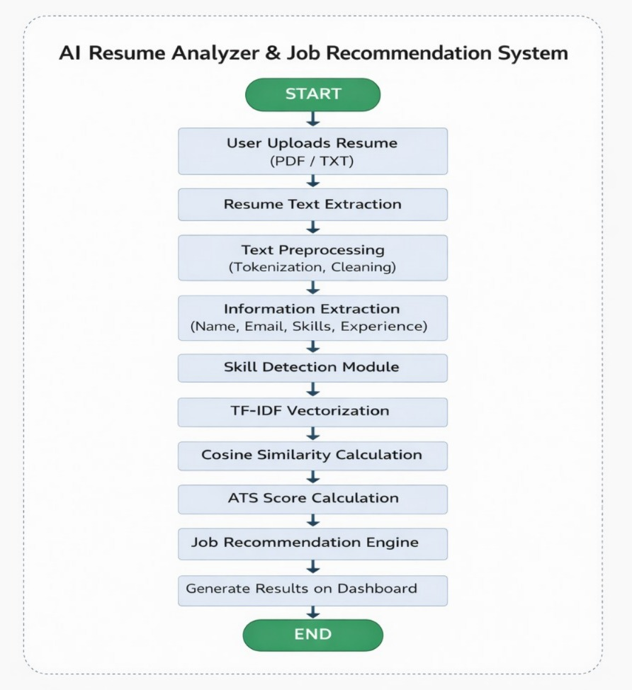
A. Data Flow Diagram
B. Sample Coding
Complete Intelligence Engine (backend_main.py)
This is the heartbeat of the project, containing all NLP extraction and ML scoring logic.
Coding :
# backend_main.py (Core Snippet)
from fastapi import FastAPI, UploadFile, File, HTTPException, Header
from fastapi.middleware.cors import CORSMiddleware
import re, math, httpx

app = FastAPI(title="AI Resume Analyzer")

# Enable CORS for frontend communication
app.add_middleware(CORSMiddleware, allow_origins=["*"], allow_methods=["*"], allow_headers=["*"])

@app.post("/analyze")
async def analyze_resume(request: TextAnalysisRequest):
text = request.resume_text

# 1. NLP Feature Extraction
skills = extract_skills_from_text(text)
sections = detect_sections(text)
exp_level = estimate_experience_level(text)

# 2. ML Scoring (100-point system)
scores = score_resume(text, skills, sections)

# 3. Semantic Job Matching (TF-IDF)
top_jobs = []
for job in JOB_DATABASE:
similarity = tfidf_cosine_similarity(text, job["description"])
top_jobs.append({
"title": job["title"],
"match_percentage": round(similarity * 100 * 1.8, 1)
})

return {
"candidate": {"name": extract_name(text), "level": exp_level},
"skills": skills,
"scores": scores,
"top_jobs": sorted(top_jobs, key=lambda x: x["match_percentage"], reverse=True)[:5]
}
UI/UX Architecture (index.html)
The frontend uses a "Glassmorphism" design system with high-performance CSS animations.
Design Tokens (CSS)
:root {
--teal: #00d4aa;
--bg: #030912;
--glass: rgba(255, 255, 255, 0.04);
--teal-glow: #00d4aa40;
/* Sophisticated palette for premium 'Axiom' feel */
}

/* Hexagonal Logo Animation */
.logo-hex {
clip-path: polygon(50% 0%, 100% 25%, 100% 75%, 50% 100%, 0% 75%, 0% 25%);
animation: hex-pulse 4s ease-in-out infinite;
}

Advanced Features (JS)
The dashboard includes client-side intelligence for immediate feedback.
// Radar Chart Visualization
function renderRadarWidget(s) {
const canvas = document.getElementById('radarCanvas');
const ctx = canvas.getContext('2d');
// Draws a 6-axis radar polygon representing the resume's strength
}

// Career Trajectory Forecast
function renderTimeline(nodes) {
// Renders a vertical roadmap of "Now" -> "Next Step" -> "Future Goal"
}

// Job Keyword Scanner
async function runKeywordScan() {
// Compares CV keywords vs JD keywords in real-time
// Highlights MISSING words in RED and PRESENT words in TEAL
}
Frontend Intelligence (Standalone Dashboard)
The frontend is a single-file React-like dashboard that handles PDF parsing and communicates with the backend.
/* index.html (JS Snippet) */

// 1. PDF Parsing using PDF.js
async function parsePDF(file) {
const buf = await file.arrayBuffer();
const pdf = await pdfjsLib.getDocument({ data: buf }).promise;
let text = '';
for (let i = 1; i <= pdf.numPages; i++) {
const pg = await pdf.getPage(i);
const ct = await pg.getTextContent();
text += ct.items.map(x => x.str).join(' ') + '\n';
}
return text;
}

// 2. AI Analysis Trigger
async function runAnalysis(type) {
if (!resumeText) return;

// Prepare dynamic AI prompts based on analysis type
const prompts = {
full: `Perform a COMPLETE DEEP ANALYSIS of my resume...`,
score: `Score my resume out of 100 with sub-score breakdowns...`,
ats: `Perform a full ATS audit and identify red flags...`
};

// Dispatch to Backend API
const response = await fetch('/analyze', {
method: 'POST',
body: JSON.stringify({ resume_text: resumeText })
});

const data = await response.json();
renderResults(data); // Custom UI rendering logic
C. Sample Input
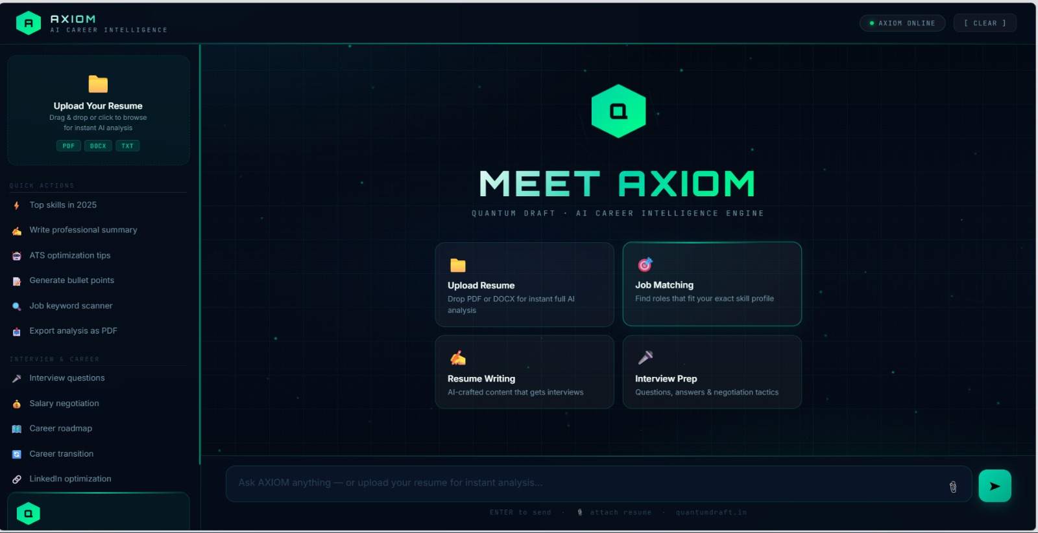

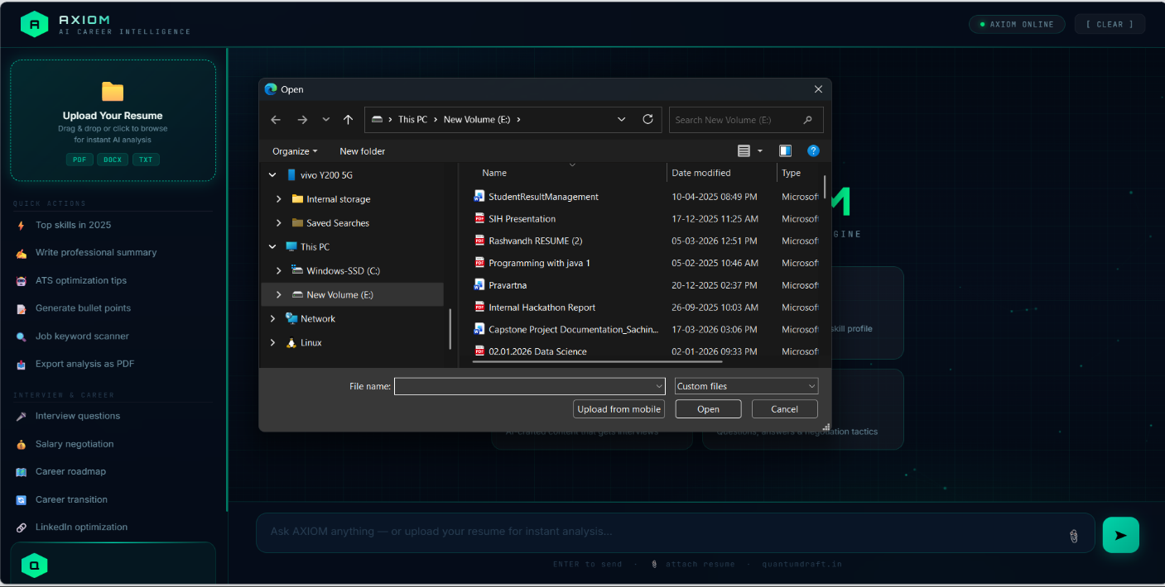

D. Sample Output
